JONATHAN JAVIER - Wonsulting

ARUSH AGGARWAL – Tandoori Thela



Arush Aggarwal, a 22-year-old senior from our Institute, is not just a 4th Year B.E. Chemical Engineering student, but also a budding entrepreneur. Born in Ludhiana, Punjab, he has shown remarkable entrepreneurial spirit and a knack for innovation.

In the even semester of 2021-22, Arush, along with a peer, came up with a unique start-up idea. The venture, named “Tandoori Thela”, is a fresh take on the food ordering system, defined as a “Cloud Kitchen”. Instead of setting up a physical restaurant, they partnered with local food outlets. This innovative approach allowed them to outsource food orders to these outlets, thereby bringing them under one umbrella. This model streamlined the food ordering process and provided a platform for local outlets to reach a wider customer base.

The strategic timing of their operations was another testament to their business acumen. They recognized that the demand for quick food delivery at night increased exponentially during exam periods. By aligning their peak operation time with this demand, they were able to capitalize on it effectively.

In conclusion, Arush Aggarwal’s entrepreneurial journey with “Tandoori Thela” is a remarkable example of innovation, strategic planning, and effective resource utilization. His venture not only serves as an inspiration for young entrepreneurs but also contributes to the local economy by partnering with local food outlets. His story is a testament to the fact that with the right idea, strategy, and execution, one can make a significant impact in the entrepreneurial world.

BIG FIVE PERSONALITY TEST

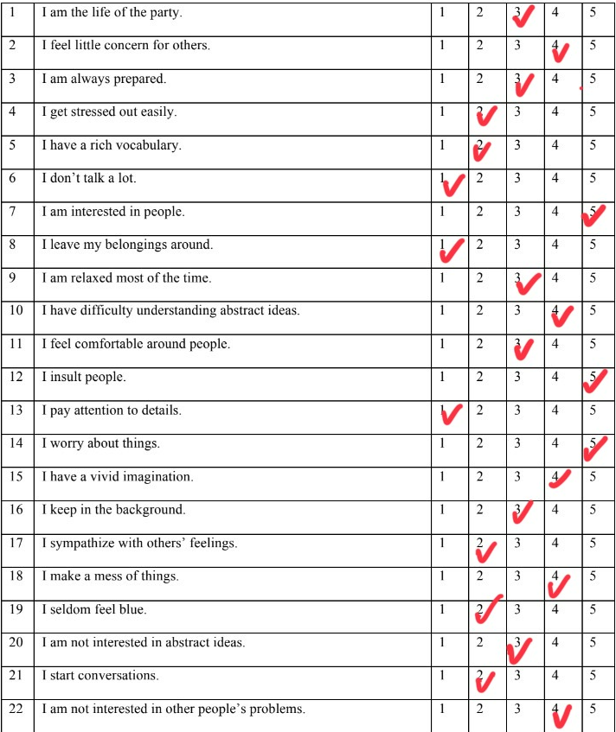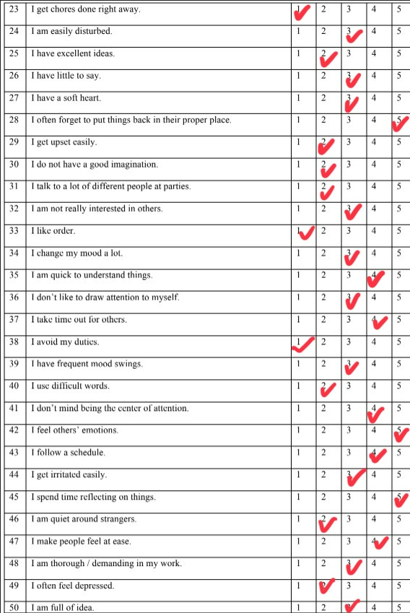

Arush Aggarwal’s Big-Five Personality Test scores:

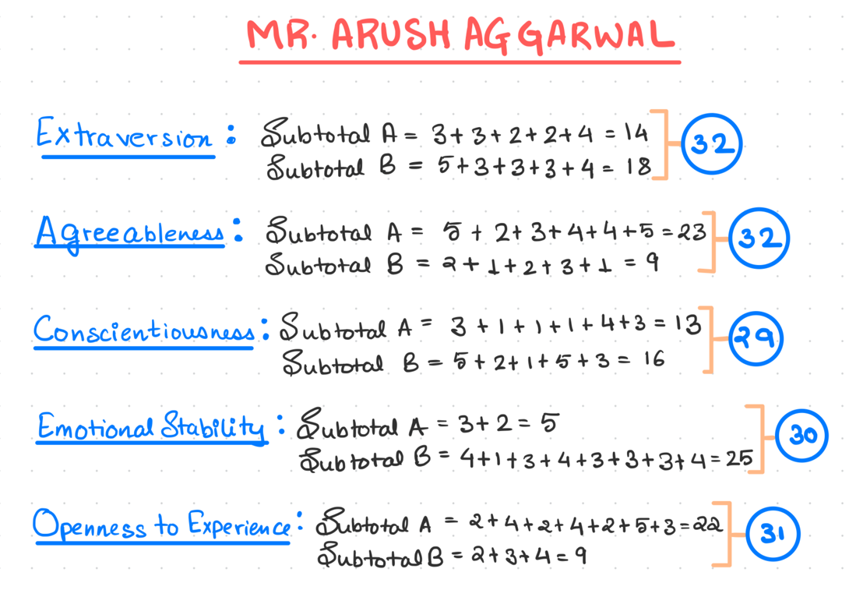

Now let’s analyse his test scores:

1. **Extraversion: 32**

Tendency to understand other’s opinions, energy, assertiveness, positive emotions, social comfortableness, tendency to seek stimulation in the company of others’ talkativeness. Arush scores on the extroverted side of the scale and is a sociable person. Meeting him really justifies his score as he seemed to be a very energetic and outgoing person who was really easy to talk to.

1. **Agreeableness: 32**

A characteristic to be compassionate cooperate & respect other’s opinion rather than being suspicious towards others. From the score it is evident that Arush has a higher tendency to be agreeable and flexible. While talking about his endeavours he greatly spoke about the adjustments and understanding mindset he had to keep while starting of on his entrepreneurial journey which is a further proof to his nature of being an agreeable person. He also talked about the importance of being able to put your point forth in a strong fashion and suggested that being too agreeable does not work well for a company that is just starting from scratch.

1. **Conscientiousness: 29**

Conscientiousness is the characteristic that shows self-discipline, act dutifully and aim for achievement and planned rather than spontaneous behaviour, organized and dependability. Arush scored around the middle which suggests that he knows when to be flexible and when to be focussed. I personally believe that this trait can be very helpful as due to being moderately conscientious Arush is easily able to change his mindset to be more focused on things that are important and be flexible when needed as this duality is greatly helpful when dealing with a large array of issues which might need both the sides of the conscientious scale.

1. **Emotional Stability: 30**

Tendency to experience unpleasant emotions easily, such as anger, anxiety, depression or vulnerability. Arush scores on the emotionally stable side of the spectrum. While talking to Arush I noticed that while he was very easy to talk to, his words were carefully framed which suggested a clear-thinking mindset. His aura showed his optimistic and confident nature.

1. **Openness: 31**

Openness is the degree of intellectual curiosity, creativity, and an urge for novelty. Arush is open to new experiences and scores well in this regard. Arush is an explorer with an open mind and humorous nature which comes through while on a conversation with him.

**Conclusion:**

Based on the given scores, Arush Aggarwal is a well-rounded individual with a balanced personality profile. His scores indicate that he is sociable and extroverted, open to new experiences, and tends to be agreeable and flexible. He shows a good level of conscientiousness, indicating self-discipline and a preference for planned rather than spontaneous behaviour. His score on emotional stability suggests that he is generally calm and less likely to experience negative emotions easily. Overall, these traits contribute to his success as an entrepreneur and make him a valuable team member in diverse settings. His openness to new experiences and intellectual curiosity aligns well with his entrepreneurial spirit, and his agreeableness and extroversion likely contribute to his ability to work well with others. His emotional stability could help him navigate the ups and downs of entrepreneurial ventures. In conclusion, Arush’s personality traits align well with his accomplishments and endeavours as well as his mannerisms while in a conversation with an absolute stranger like me.